Report Learning Python + FastAPI

Chú ý:

* Phân biệt biến mutable và immutable
* Cấu trúc một project python
* Cách import module giữa các file trong project
* List comprehension (cái này dùng nhiều và nhanh hơn loop for )

11/8:

[Python] Nội dung đã học:

* Loop, Function, Random
* List [], Dictionary {}  
  dict_name[key_name] = value
* Bắt đầu học OOP

**NOTE:**

Section 24: Files, Directories, Paths  
Section 26: List comprehension: <https://www.w3schools.com/python/python_lists_comprehension.asp>

**FastAPI:**

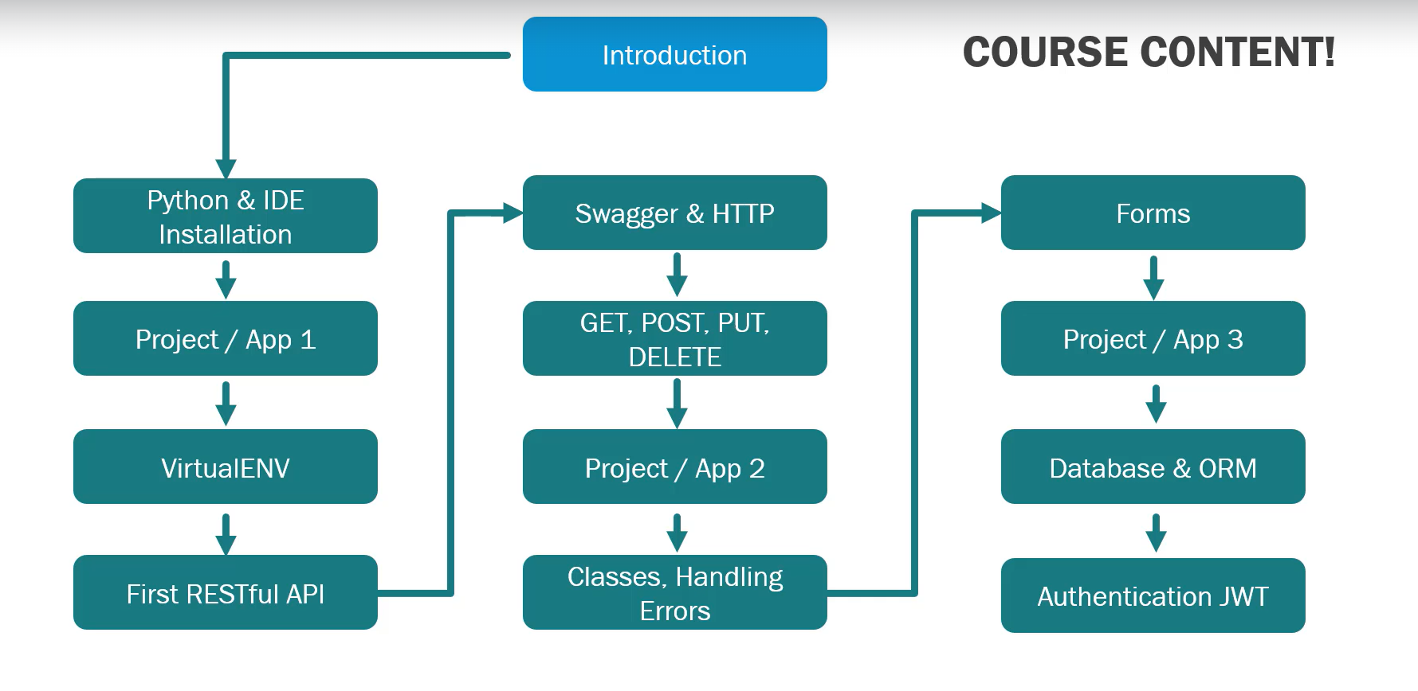

Expectation:

18/8: Sec 1 – Sec 6

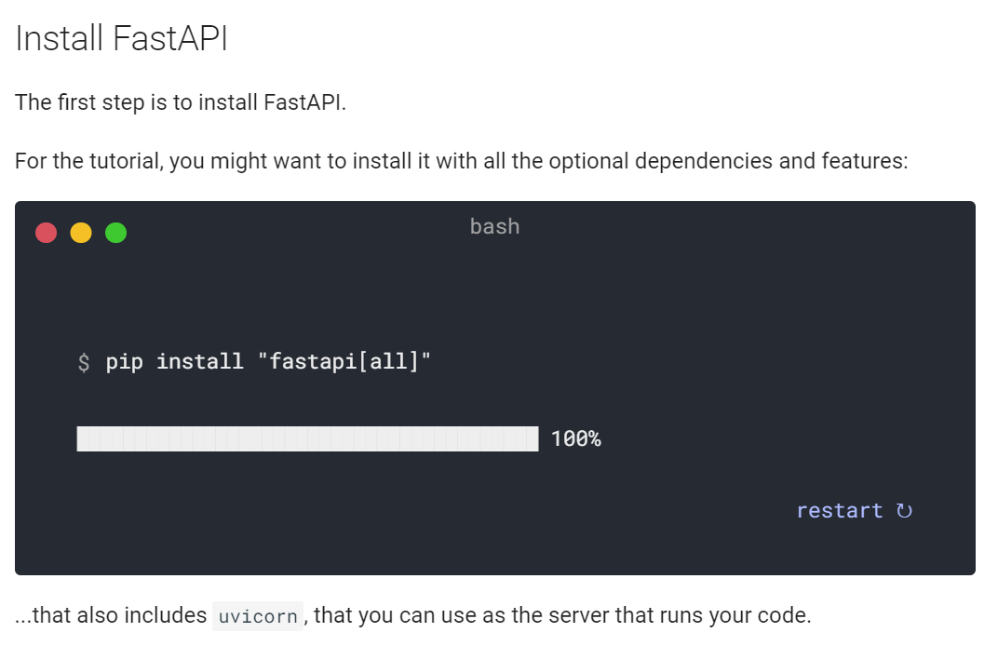

**Start Environment**

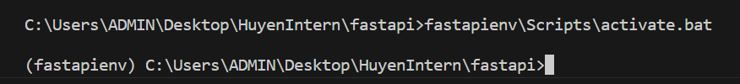

**Run Server**



**Swagger UI**

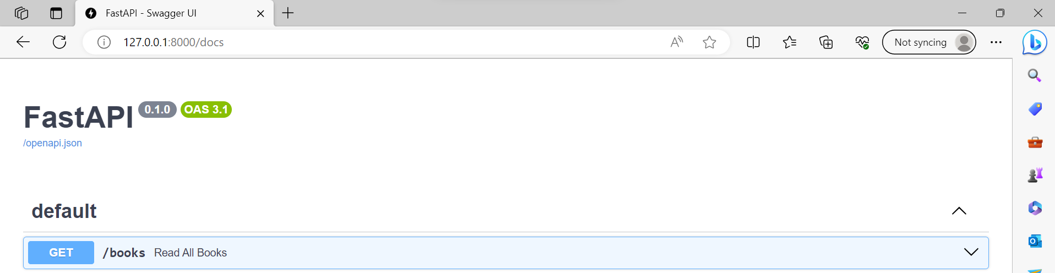

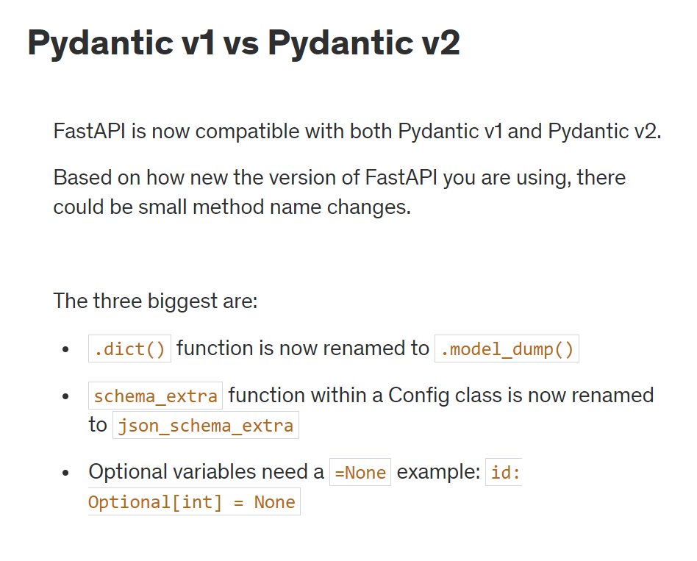

**Pydantic Request Validation**

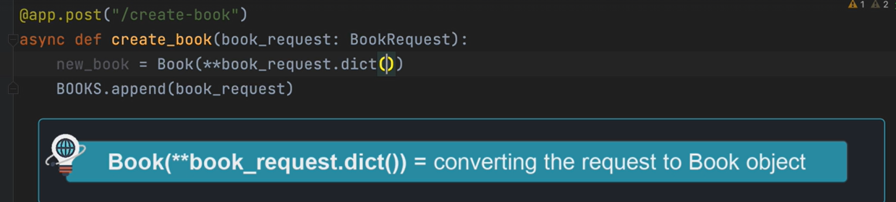

1. **GET request method**

**Path Parameters(/) & Query Parameters (?)  
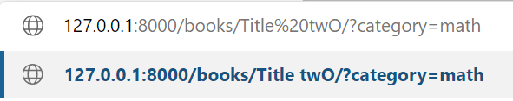**

1. **POST request method**

**Fields – Data Validation**

from pydantic import BaseModel

class BookRequest(BaseModel):

    id:int

    title: str = Field(min_length=3)

    author: str = Field(min_length=1)

    description: str = Field(min_length=1, max_length=100)

    rating: int = Field(gt=0, lt=6)

Pydantics is used for data parsing and data validation

What is the purpose of class Config within our class BookRequest(BaseModel)?  
-> To create a more descriptive request within our Swagger documentation

**SQLALCHEMY**

* Connect database

Files: models.py: DTB Tables, main.py: create DTB connection for API